###### **http://static.wixstatic.com/media/ed18ab7c9cf4d6ffbb63395cc1e9a4a3.png_srz_571_57_75_22_0.50_1.20_0.00_png_srz**

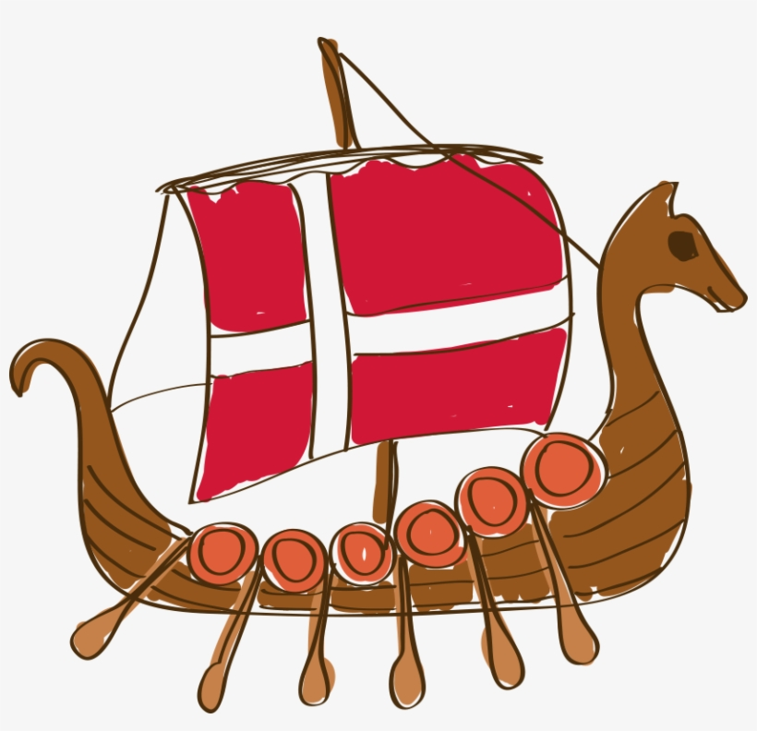

Ms. Valerie Brown

Sixth Grade Math 6 Accelerated

NWMS Middle School

336.605.3333

brownv@gcsnc.com

Course Overview

The goal of 6th Grade Math is to develop problem solving skills within each student to enable them to take the skills learned in class and apply them to real world problems. The emphasis on word problems will challenge and develop each student’s critical thinking skills. The result should be a student that is prepared to excel on the End of Grade test, as well as being prepared for future success in Math 7.

GCS uses “Open-Up Resources” Curriculum. You may access the student version with the following link. [(Open-Up Resources-Student Versions).](https://access.openupresources.org/curricula/our6-8math-nc/en/grade-6/index.html) You will also find this link on my website and canvas home page. Your child will be provided workbooks for each unit this year. Your child can write in the workbooks as well as make notes. In each lesson you will find activities that are teacher guided, summary and practice problems. We may not assign practice problems for each lesson, but your child can practice these problems for extra practice.

|  |
| --- |
| Classroom Supplies  *(Needed each day)* |
| * Notebook paper * OUR Workbook * Pencils * Red pen * Highlighter * Colored pencils * Glue Stick * Ruler |

|  |  |
| --- | --- |
| **Accelerated**  **Math 6 - Open-Up Resources CURRICULIUM** | |
| **A6 Unit 1** | Areas and Surface Areas |
| **A6 Unit 2** | Ratios, Rates, and Percentages |
| **A6 Unit 3** | Fractions and Decimals |
| **A6 Unit 4** | Equations and Expressions |
| **A6 Unit 5** | Proportional Relationships |
| **A6 Unit 7** | Rational Numbers |
| **A7 Unit 3** | Writing and Solving Equations |
| **M6 Unit 8** | Data Sets and Distributions |

# Grading and Evaluation

# PowerSchool vs. Canvas Grades – PowerSchool is the OFFICIAL grades for your child. These are the grades on your child’s progress report and report card. The grades from Canvas and other assignments will all be entered in PowerSchool where it will calculate their actual grade in the course.

## Homework Grades – Homework in this class is designed to help reinforce the concept that was taught that day. It is important for students to practice and study the material in their notes. Homework should be completed at home, turned in on time, and every problem should have been attempted to receive full credit. If homework is not turned in on time students will have the opportunity to turn it in late for partial credit. A satisfactory homework paper is one that is turned in on time and shows that the effort was made to try all the assigned problems.

## Skills Checks – Skills check are a spiral review of concepts for practice. While we must continue with GCS pacing guides, skills checks allow us to practice previous skills till we see mastery of the concepts. During eLearning, we are assigning 5 problems through DESMOS. This allows us to see student work as students write on their screen. We will spend a few minutes of class time to allow questions from students. We assign Skills Checks Monday-Thursday with a quiz on Friday. If students do not understand a concept on Monday, your child needs to ask questions so that they can practice for the quiz on Friday.

***(Monday-Thursday skills checks are a completion grade. They must attempt each problem with showing work to make a 100%.)***

## Quizzes – Formative assessments are given weekly. These assessments inform teachers of quick mastery of concepts taught that week. We will give weekly Skills Check Quizzes on Friday (Your child practices Monday – Thursday on previously taught math concepts). We will also give a quiz on the curriculum we are teaching for that week to check for mastery. Your child may have one-two quizzes a week. It is important that your child practices each day the math assignment to be successful! We give few problems to allow your child time to complete the problems with explanation.

## Tests – Summative assessments are given usually every two weeks. These assessments inform teachers of mastery of concepts taught mid or entire units. We assign a few practice problems Monday – Thursday for students to practice math material taught daily. Student are most successful for practicing daily and NOT waiting till the day before an assessment. We announce the test two -three days prior to a test.

|  |  |
| --- | --- |
| Test/Projects-(Actual grade) We usually have a test every 2 weeks. If test cannot be taken on the day assigned, then the teacher must be notified to make-up the test. Failure to make up a test will result in a grade of zero for that test. | 45% |
| Quizzes – (Actual Grade) We usually have a Skills Check Quiz once a week and occasionally another quiz on the curriculum we are teaching for that week. If the quiz cannot be taken on the day assigned, then the teacher must be notified to make-up the test. Failure to make up a quiz will result in a grade of zero for that quiz. | 35% |
| Classwork – (Completion Grade) – Your child must attempt each problem and show their work on each problem to make a 100% | 10% |
| **Homework** – (Completion Grade) – Your child must attempt each problem and show their work on each problem to make a 100%. Skills check are homework grades. | 10% |